**Project Design Phase-II**

**Data Flow Diagram &User Stories**

|  |  |
| --- | --- |
| Date | 21 October 2022 |
| Team ID | PNT2022TMID03607 |
| Project Name | Corporate Employee Attrition Analysis |
| Maximum Marks | 4 Marks |

**Data Flow Diagrams:**

A Data Flow Diagram (DFD) is a traditional visual representation of the information flows within a system. A neat and clear DFD can depict the right amount of the system requirement graphically. It shows how data enters and leaves the system, what changes the information, and where data is stored.

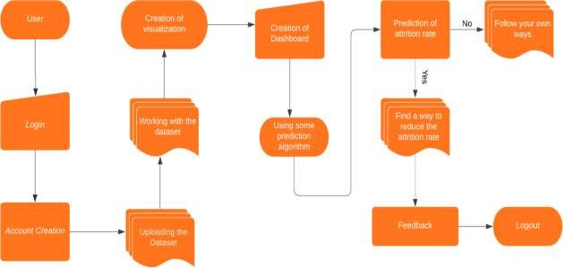

**User Stories**

Use the below template to list all the user stories for the product.

|  |  |  |  |  |  |  |
| --- | --- | --- | --- | --- | --- | --- |
| **User Type** | **Functional**  **Requirement (Epic)** | **User**  **Story**  **Number** | **User Story / Task** | **Acceptance criteria** | **Priority** | **Release** |
| Customer (Web user) | Registration | USN-1 | As a user, I can register for the application by entering my email, password, and confirming my password. | I can access my account / dashboard | High | Sprint-1 |
|  |  | USN-2 | As a user, I will receive confirmation email once I have registered for the application | I can receive confirmation email & click confirm | High | Sprint-1 |
|  |  | USN-3 | As a user, I can register for the application through Facebook | I can register & access the dashboard with Facebook Login | Low | Sprint-2 |
|  |  | USN-4 | As a user, I can register for the application through Gmail | I can register & access the dashboard with Gmail Login | Medium | Sprint-1 |
|  | Login | USN-5 | As a user, I can log into the application by entering email & password | I can access my account / dashboard | High | Sprint-1 |
|  | Dashboard | USN-6 | Uploading the Dataset | I can be able to upload my dataset | High | Sprint 2 |
|  |  | USN-7 | Working With Dataset | I can be able to access my dashboard | High | Sprint 2 |
|  |  | USN-8 | Visualization | I can be able to view the visual attrition rate of my dataset | High | Sprint 3 |
|  |  | USN-9 | Working with Dashboard | I can be able to view the various views of the attrition rate | High | Sprint 3 |
| Customer Care Executive |  | USN-10 | Asking Help / Feedback | I can be able to ask help if I can face any issues or  problems while using the webpage | Medium | Sprint 4 |
| Administrator |  | USN-11 | Managing the Database | I can assure that my data is in secure state | High | Sprint 4 |
|  |  | USN-12 | Managing the over all process | I can assure that my data and process is going good | High | Sprint 4 |